**Pizza Sales Analysis SQL Report 2024**

1. **Retrieve the total number of orders placed.**

Select count(order_id) as total_orders from orders;

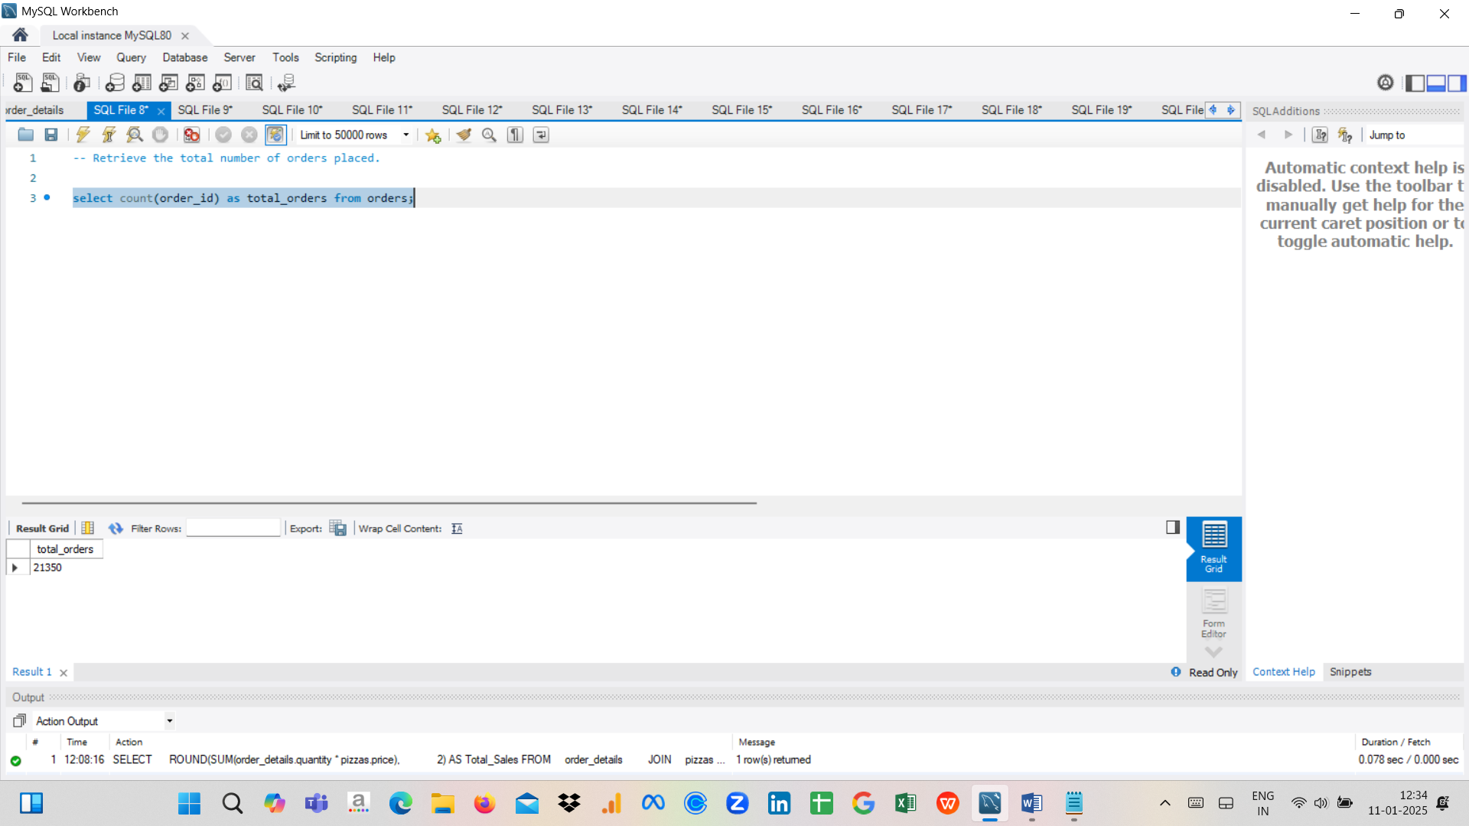

1. **Calculate the total revenue generated from pizza sales.**

SELECT ROUND(SUM(order_details.quantity * pizzas.price),2) AS Total_Sales

FROM order_details

JOIN pizzas ON order_details.pizza_id = pizzas.pizza_id

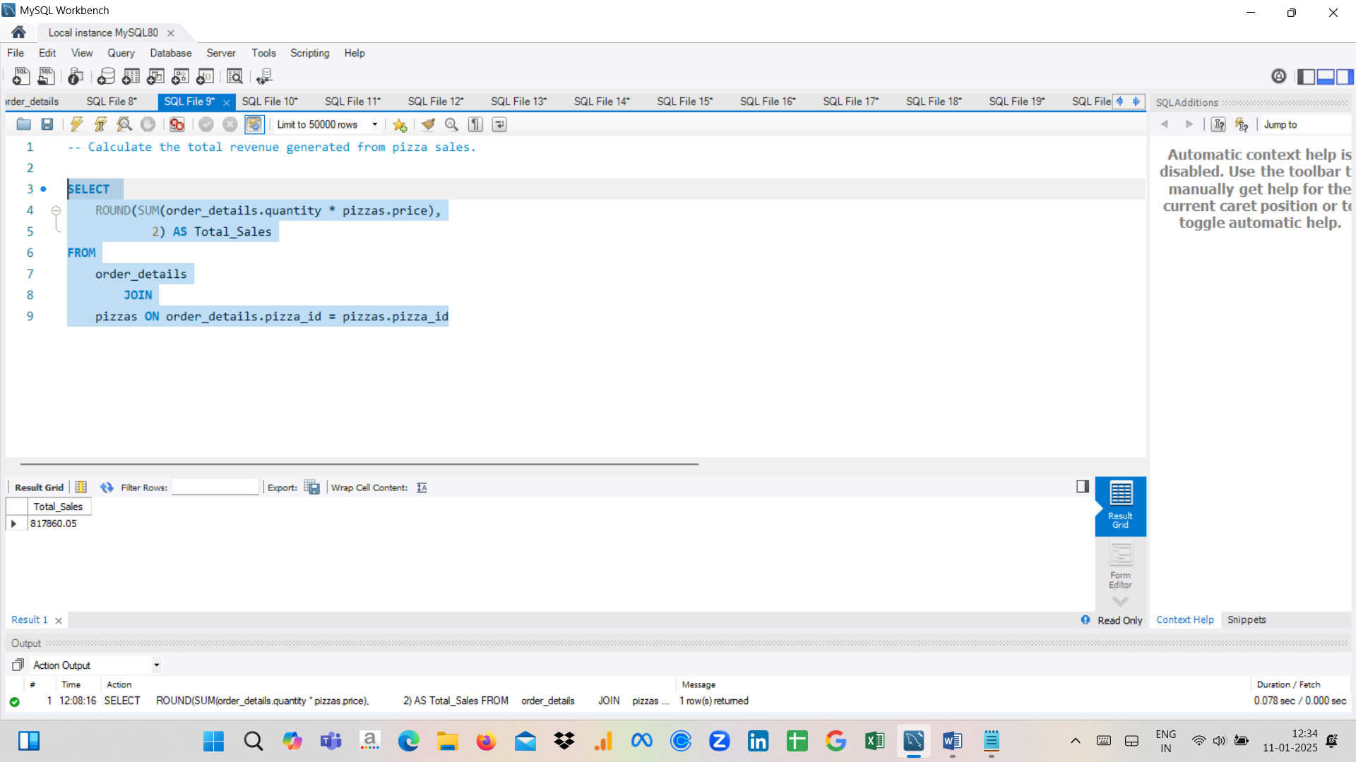

1. **Identify the highest-priced pizza.**

Select pizza_types.name, pizzas.price from pizza_types join pizzas

on pizza_types.pizza_type_id = pizzas.pizza_type_id

order by pizzas.price desc

limit 1;

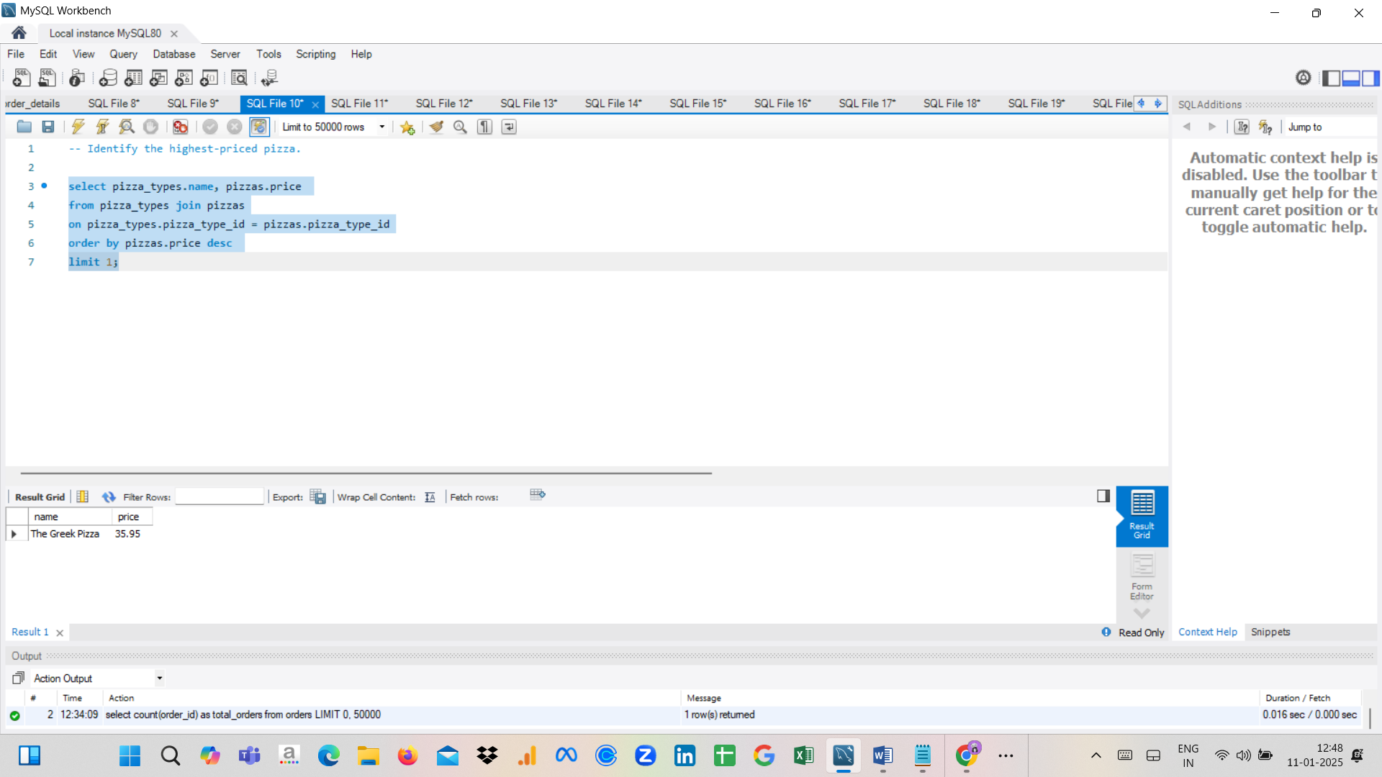

1. **Identify the most common pizza size ordered.**

SELECT pizzas.size, COUNT(order_details.order_details_id) AS order_Count

FROM pizzas

JOIN order_details ON pizzas.pizza_id = order_details.pizza_id

GROUP BY pizzas.size

ORDER BY order_Count DESC;

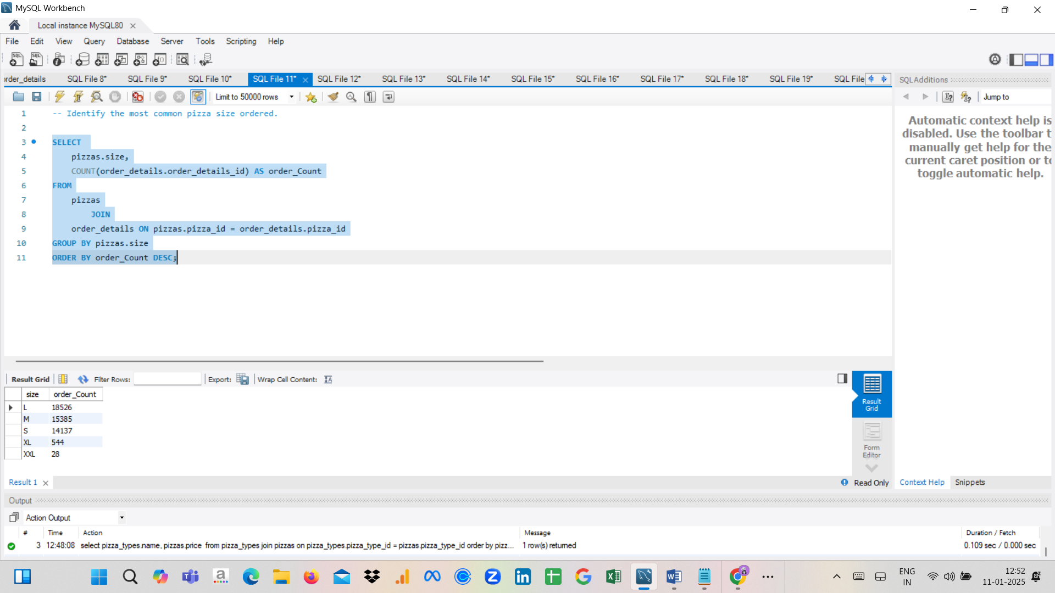

1. **List the top 5 most ordered pizza types along with their quantities.**

select pizza_types.name, sum(order_details.quantity) as quantity

from pizza_types

join pizzas

on pizza_types.pizza_type_id = pizzas.pizza_type_id

join order_details

on order_details.pizza_id = pizzas.pizza_id

group by pizza_types.name

order by quantity desc limit 5;

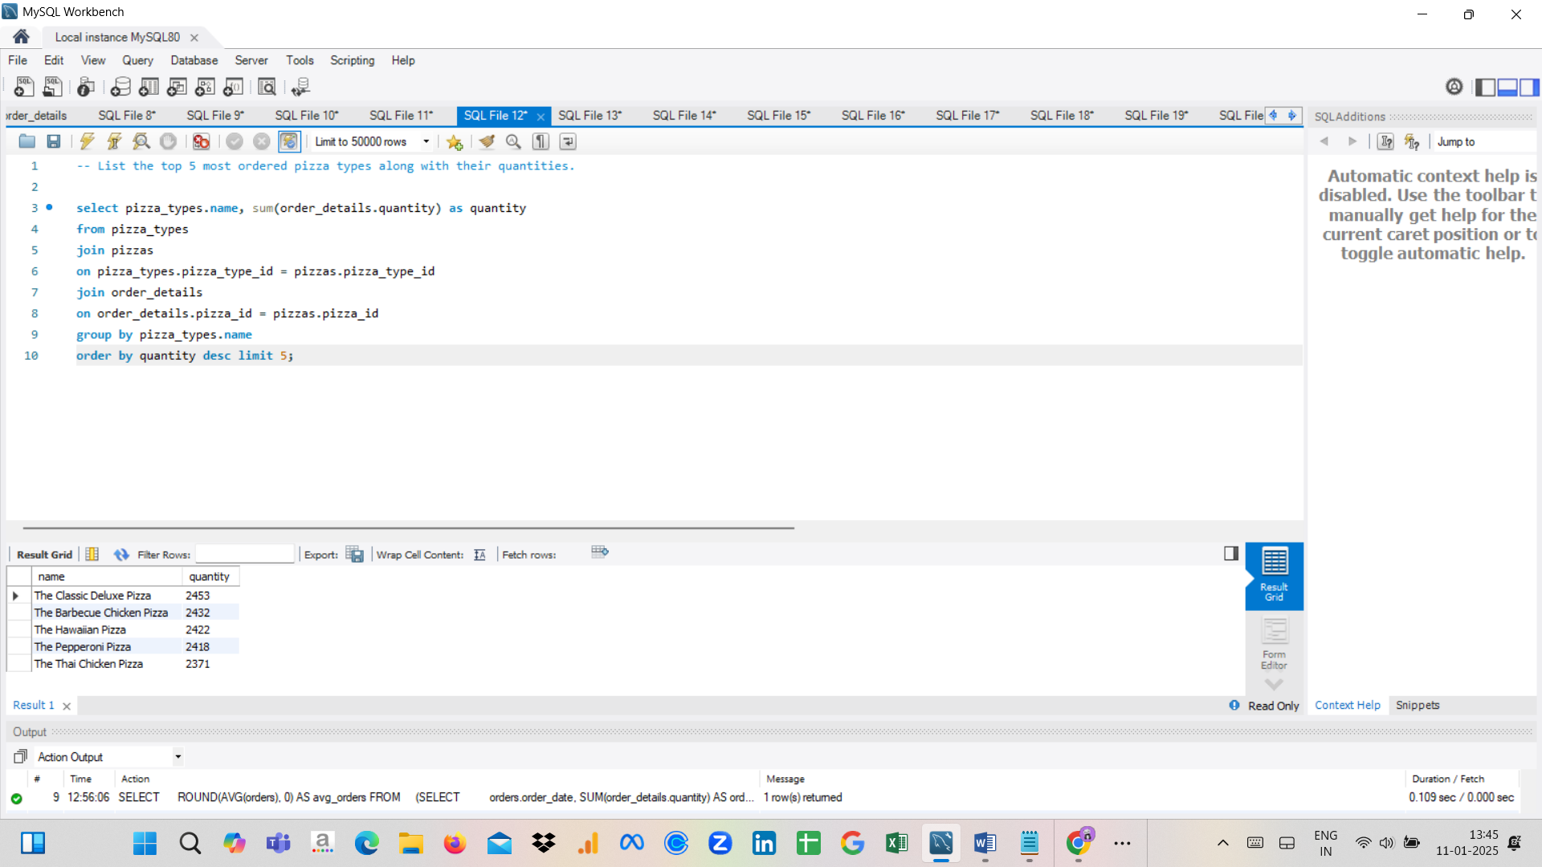

1. **Join the necessary tables to find the total quantity of each pizza ordered.**

select pizza_types.category, sum(order_details.quantity) as quantity

from pizza_types

join pizzas

on pizza_types.pizza_type_id = pizzas.pizza_type_id

join order_details

on order_details.pizza_id = pizzas.pizza_id

group by pizza_types.category;

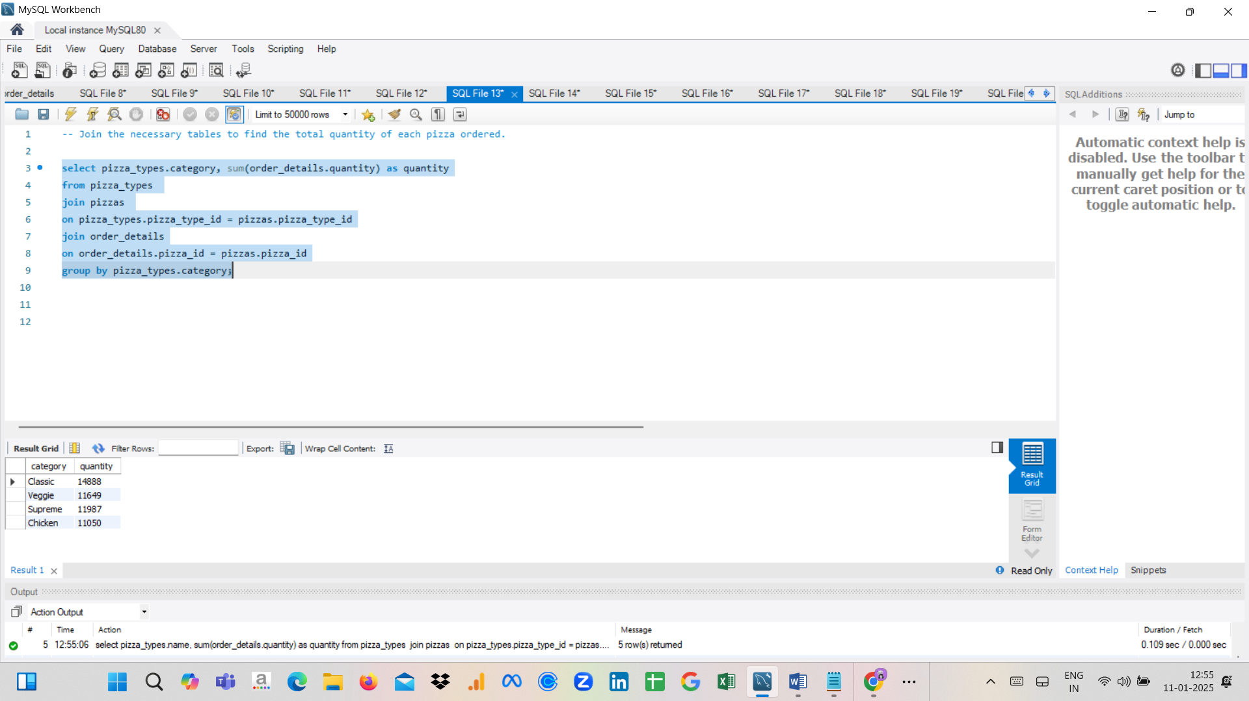

1. **Determine the distribution of orders by hour of the day.**

SELECT HOUR(order_time), COUNT(order_id) AS order_count

FROM orders

GROUP BY HOUR(order_time);

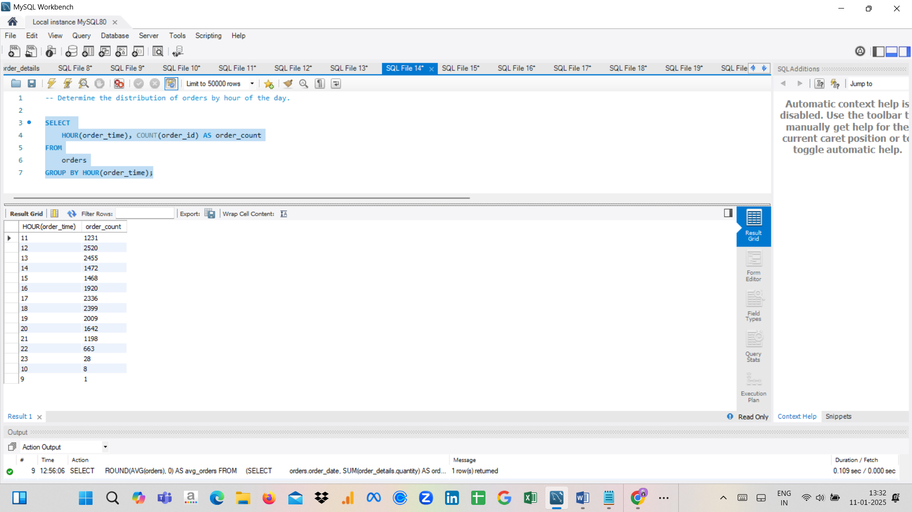

1. **Join relevant tables to find the category-wise distribution of pizzas.**

select category, count(pizza_type_id) as pizzas from pizza_types

group by category;

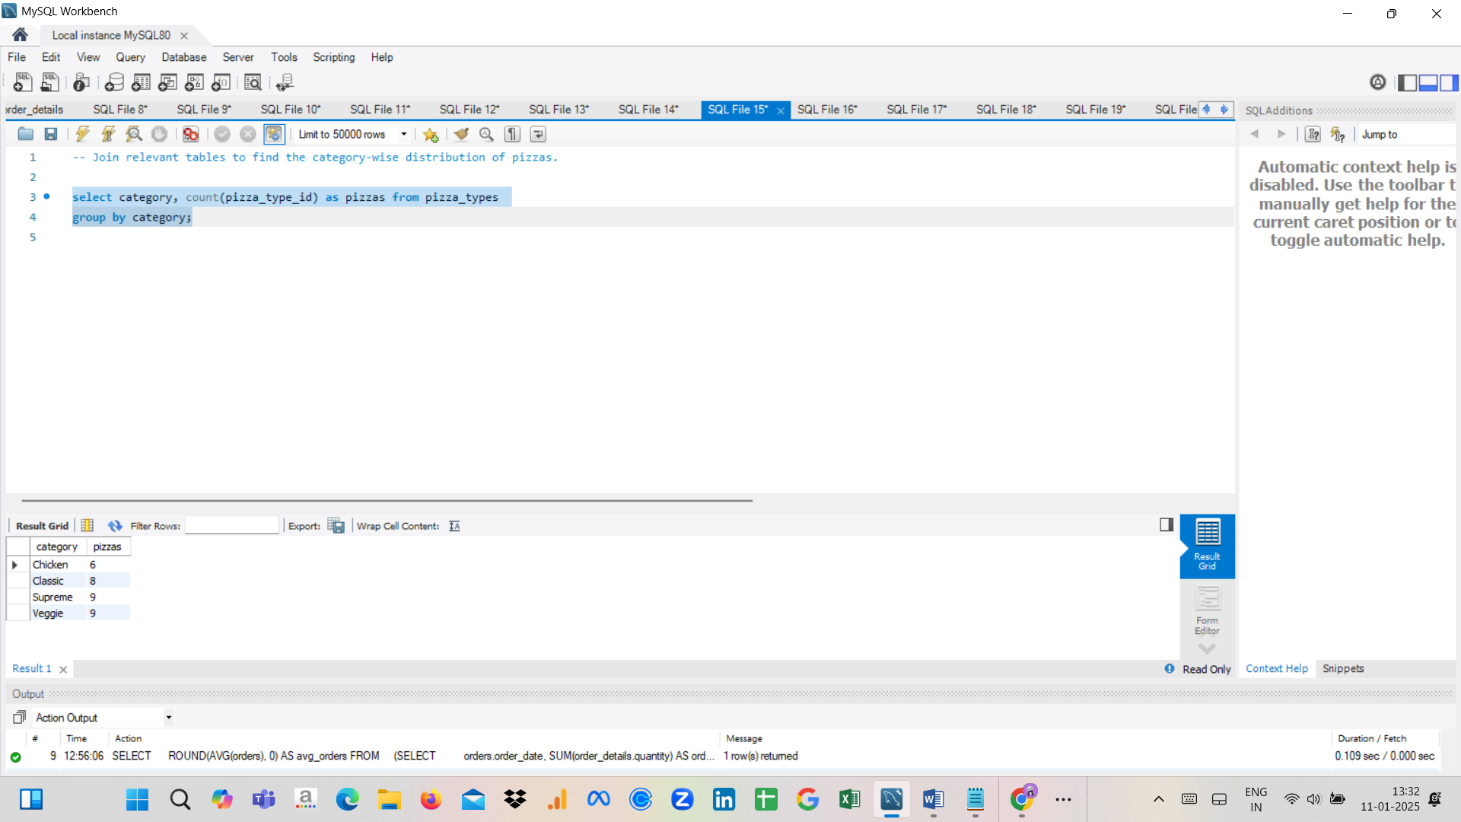

1. **Group the orders by date and calculate the average number of pizzas ordered per day.**

SELECT ROUND(AVG(orders), 0) AS avg_orders

FROM (SELECT orders.order_date, SUM(order_details.quantity) AS orders

FROM orders

JOIN order_details ON orders.order_id = order_details.order_id

GROUP BY orders.order_date) AS order_quantity;

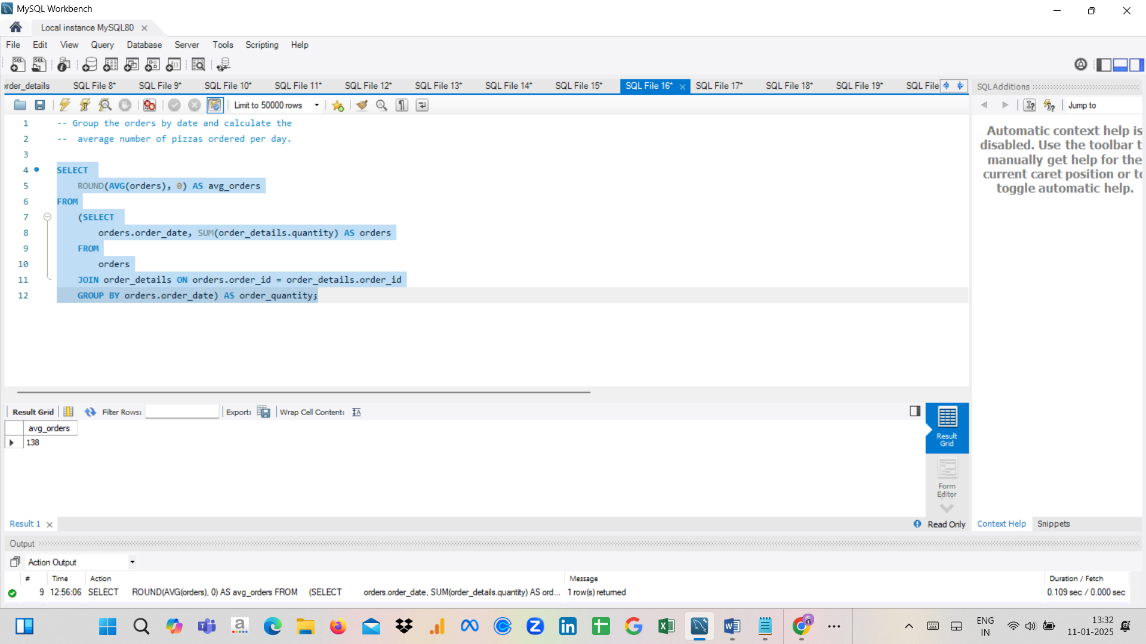

1. **Determine the top 3 most ordered pizza types based on revenue.**

SELECT pizza_types.name, SUM(order_details.quantity * pizzas.price) AS revenue

FROM pizza_types

JOIN pizzas ON pizzas.pizza_type_id = pizza_types.pizza_type_id

JOIN order_details ON order_details.pizza_id = pizzas.pizza_id

GROUP BY pizza_types.name

ORDER BY revenue DESC

LIMIT 3;

